2nd Annual Westford Spring Festival & Contest at the
Westford Regency Inn and Conference Center
March 20 – April 15, 2020
You are invited………..
The Westford Family FunFest and Westford Regency Inn & Conference Center invites you, your organization, schools, civic, business, community, church groups to decorate an artificial wreath or Gingerbread Creation (gingerbread, cardboard or other materials) , make a Fairy Garden/Gnome House or other Easter or Spring Decoration for the 3rd Annual Westford Spring Festival. The Festival creations will be on display at the Westford Regency Inn and Conference Center from March 20 – April 15, 2020
As part of the Festival you or your organization can decorate an artificial wreath, gingerbread creation, make a Container/ Fairy Garden/Gnome House or other Easter/Spring Decoration in a special Spring/Easter theme. They will be located in special display areas of the Westford Regency including: Atrium, Lobby area,
Opening day will be held at the Westford Regency on Friday, March 20, 2020 voting started for the most popular wreath, gingerbread creation or Container/ Fairy Garden/Gnome House; start of the silent auction and more fun. The Westford Spring Festival is sponsored by the Westford Regency Inn, Circle Health/ Lowell General Hospital, Enterprise Bank, Westford Business Association, Whole Foods of Westford, and Emerson Hospital and others.

- The Decorated Spring/Easter Wreaths will be judged on creativity and imagination. Prizes sponsored by the Westford Regency Inn and Conference Center.
  - Prizes –Special certificates for each Category
    - First Place ($50), second place ($25) will be awarded for each division (see below).
    - Plus bragging rights for the whole year including on the Westford FunFest Website.
- Divisions :
  - Wreaths – Youth and Adults/organizations
  - Gingerbread Creations - all types - real or artificial Gingerbread creations
  - Container/Fairy Gardens (small live gardens) or Gnome Houses.
  - Other types of Spring/Easter Decorations.
- Public will vote for the “Most Popular” will receive a special prize.

Theme: 3 areas
- Spring/Easter themes - Pick the theme for your wreaths/ gingerbread creation/ Container/Fairy Garden/Gnome Houses or other Spring/Easter Decorations.
  - Artificial wreaths only.
  - Gingerbread, cardboard or other types of materials to build.
  - Single creation or scene creation - *Required to put on a sturdy base for display.
  - Container Garden or Fairy Garden/Gnome House Display – plant a Dish garden or Fairy Garden in a Container or build a Gnome house. ** only live plants can be used.
  - Other Spring/Easter Creative Decorations can be submitted too.
Signage – Theme and name of individual, organization, business or group on or near tree, wreath, gingerbread creation or Container/Fairy Garden/Gnome House.

Set-up
Wreaths/ Gingerbread Creations and Container Garden/ Fairy Gardens/Gnome House must be set-up between 2pm – 6pm on Wednesday, March 18, 2020 only (unless arrangements are made) – all areas must be kept clean and materials taken with you that are not part of the display. Special Wreath display holders will be provided. Gingerbread creations and Container Gardens or Fairy Gardens/Gnome Houses will have special areas to display creations, required to be displayed on sturdy base for Gingerbread and container for Container or Fairy Garden . The Container must be water proof – they will be watered during the Festival.

Cost: Free, if registered by March 5, 2020 $10 charge after that date – make check payable to Westford Family FunFest.

Possible Fundraiser:
If you or your organization would like to make this a fundraiser –
- The wreath, gingerbread creation, Container/Fairy Garden, and other Creative decorations can be part of the Silent Auction that is open to the public. 100% of the silent auction winning bid goes back to the person, organization or business that entered the wreath, gingerbread creation or Container/ Fairy Garden . If you would like to donate your amount to another organization, please let us know - so that winner knows who to make check out to.
  - Two divisions for Silent Auction Fundraiser:
Wreaths and Container/Fairy Gardens/Gnome House:
- Complete Wreath and Fairy Gardens with all decorations unless noted
- Pick up - , April 29, 2019 , between 3pm - 6 pm unless arrangements are made. Checks will be made out to the organization or person.
Gingerbread Creations and Creative Easter/Spring Decorations:
- Gingerbread Creations - Silent Auction checks for gingerbread creation/ creative decorations will go back to the person or organization

- OR funds can be donated to the Westford Family FunFest – Community Organization Fund.

Special Events for Spring Festival 2020
- Workshops for adults, children, families and Youth organizations will be available for Gingerbread Creations and Easter Egg Decorating by Roudenbush Community Center. Workshops will be held at the Roudenbush Community Center. For dates, time, costs and to Register – visit Roudenbush Community Center – www.roudenbush.org
All workshop projects are encouraged to enter project in the Spring Festival 2019.
- Senior and Friends Breakfast and viewing of the Festival will be offered Dates to be announced soon on website and Facebook page. .
- Breakfast with the Easter Bunny – Saturday, April 4, 2019 – 8:30 am – 11:30am with Easter Bunny photos and craft activities (support Girl Scouts). Enjoy the Breakfast buffet or order from menu. Special items for Children too. Call and Register for Breakfast at the Westford Regency Inn – 978 692-8200 ext 520.

Watch for updates at www.westford.org/funfest and Westford Family FunFest Facebook page or Spring Festival 2020 Facebook Event page – coming soon.

Visit www.westford.org/funfest for more information or send an email to funfest@westford.org for questions.
Deadline March 15, 2020 for a Free registration (see note above regarding registrations after April 1. Send/email application to: Westford Family FunFest P.O. Box 134 Westford, MA 01886 OR email to funfest@westford.org

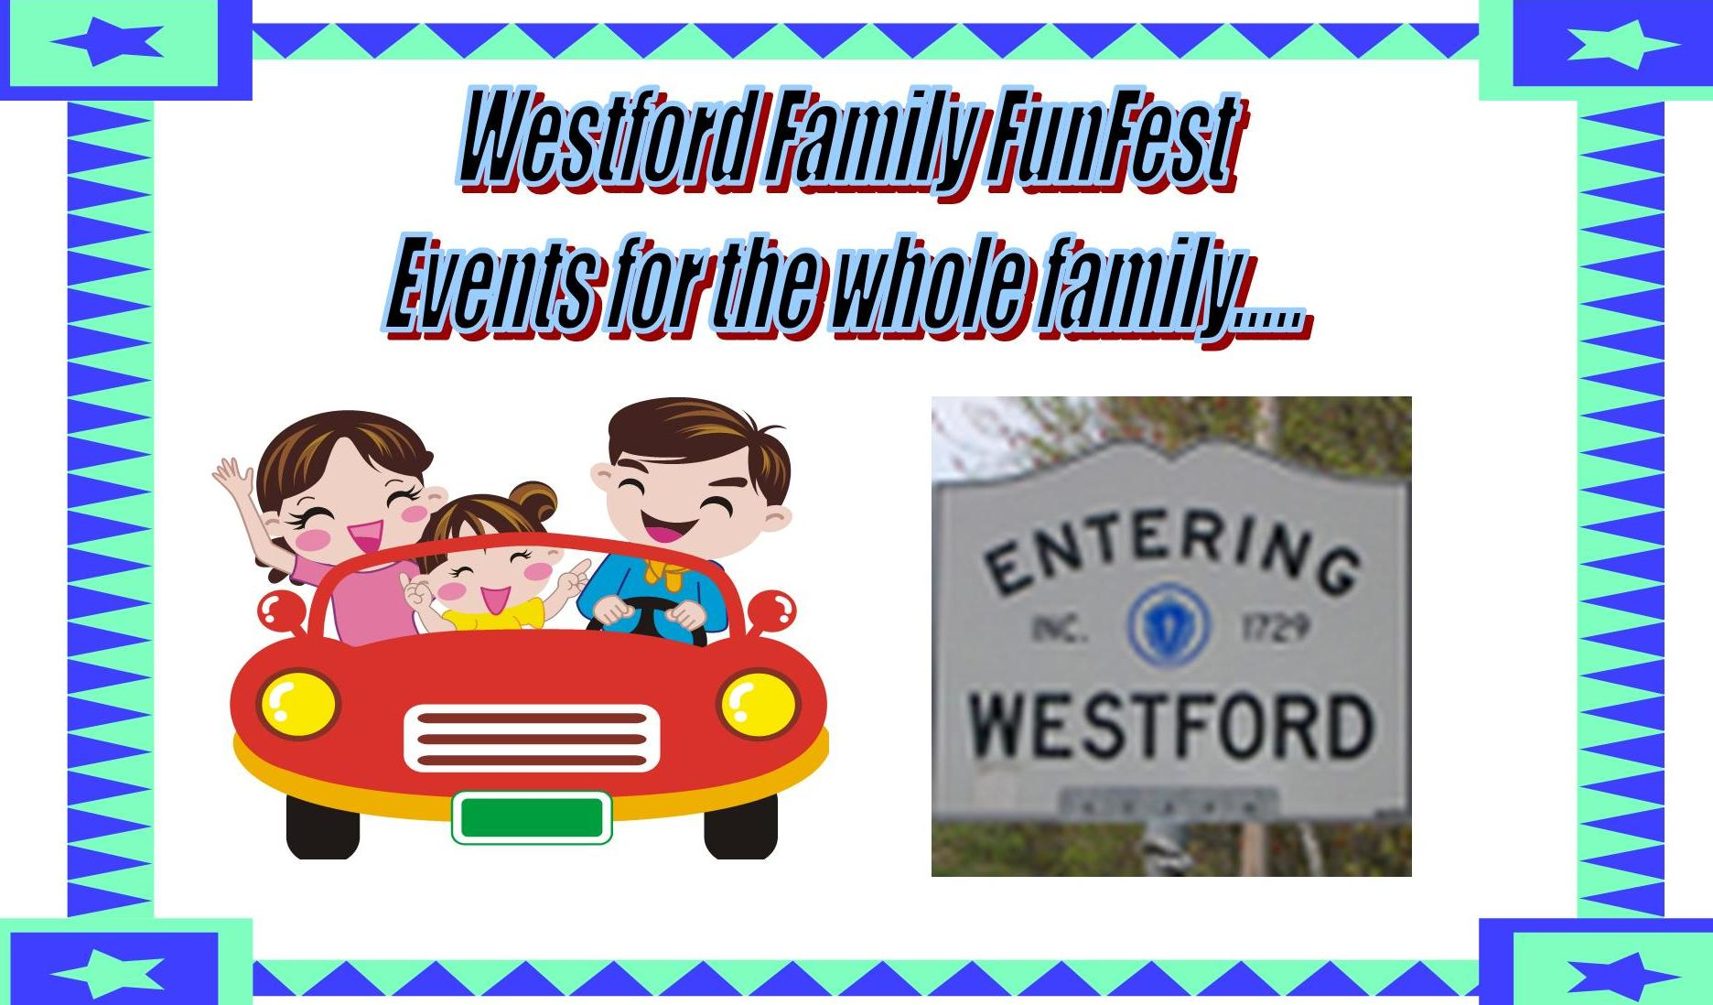

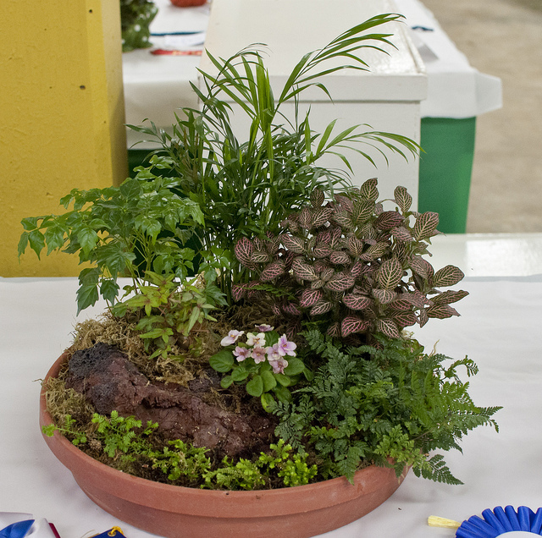 Westford Spring Festival Application 2020
Sponsored by the Westford Family FunFest and
& Westford Regency Inn March 20 – April 15, 2020

Held at the Westford Regency Inn 219 Littleton Rd. Westford, MA 01886

All Entries must fill out this section:
Name of organization, business/civic or individual: _________________________________________
Contact person(s): ______________________________________________________________________
Address__________________________________ City, State and zip code _________________________
Phone (home or business) _________________________ cell (optional) __________________________
Email _____________________________________________________________________________

Division Entered: Please check for one or more of the divisions. Give details below
__ Spring or Easter Wreath __ Creative Gingerbread – real/ artificial __ Fairy Gardens __ Gnome House Garden __ Creative Easter/ Spring Decoration

**Wreath Division ___
Name or theme ____________________
Please describe in a few words ________________________________________________________________________________________
Size of Wreath in inches across - ____________(determine placement)

**Gingerbread Creation Division: ___
Name or Theme:__________________________________ ___ Real or ___ Artificial Gingerbread materials
Please describe in a few words. ________________________________________________________________________________
Type: Single item __ OR Scene __ approximate display size _____ required to be displayed on a sturdy base.

**Container Garden/Fairy Garden/Gnome House Division:

Name or Theme:__________________________________ ___ Container Garden ___ Fairy Garden ___ Gnome House ___
Please describe in a few words. ________________________________________________________________________________
Type: approximate display size _____ Required to be displayed in a sturdy container or sturdy base Must be waterproof container – Gardens will be watered. .

**Creative Easter or Spring Decoration Division:

Name or Theme:__________________________________
Please describe in a few words. ________________________________________________________________________________
Type: approximate display size _____

Drop off and set-up on Wednesday, March 18, 2020 between the hours of 2:00pm – 6pm. (unless arrangements are made) All areas must be kept clean and materials not used as part of display must be taken. (Please respect hotel guests/employees with no excess noise)

****All wreaths/ Gingerbread creations/ Container Garden, Fairy Gardens/ Gnome Houses and Creative Spring/Easter Decorations except Silent Auction winners must be picked up by Monday, April 17, 2:00pm - 6pm, unless other arrangements have been made. Area must be left clean.

Fundraising information :
Silent Auction (which division) _________________ Yes______ or NFS(not for sale)_____
If Yes, Receive 100% of the funds from the Silent Auction bid or donate it to an organization.
Check off Division__ Wreath __ Gingerbread Creation ___ Container/ Fairy Garden __Gnome House.
_____ Creative Spring/Easter Decoration

If you would like to donate your prize or Silent Auction amount to another organization, please let us know, so that winner knows who to make check out to. ______________________________________________
If you do not have an organization – the Westford Family FunFest Community Fund is the supported organization the funds for Spring Festival 2020 event, if you like. WFFF Community Fund _______

Cost: Free, if registered by March 15, 2020 $10 after March 15, 2020 – make check payable to Westford FunFest .

Mail to Westford Family FunFest P. O. Box 134 Westford, MA 01886 or email to funfest@westford.org. You will be notified of acceptance in the Festival/Contest by email and given final instructions. Email any questions?

