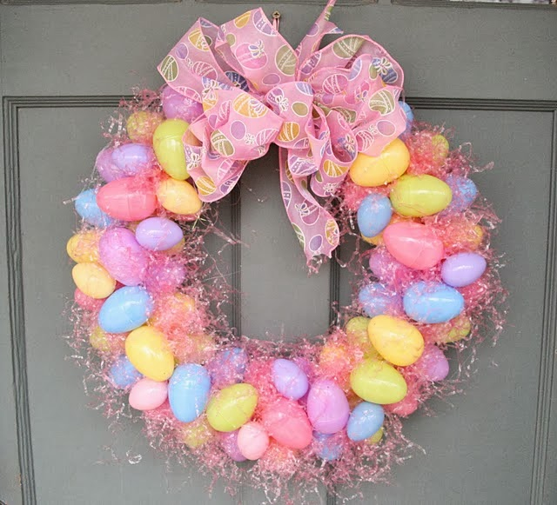1st Annual Westford Spring Festival & Contest at the 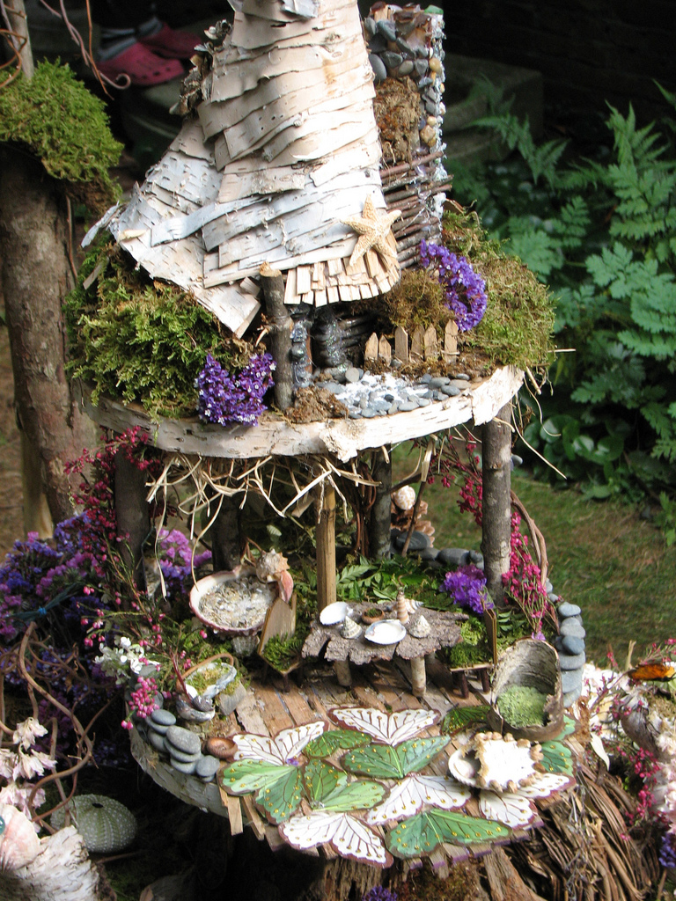
Westford Regency Inn and Conference Center
March 16 – April 2, 2018
You are invited………..
The Westford Family FunFest and Westford Regency Inn & Conference Center invites you, your organization, schools, civic, business, community, church groups to decorate an artificial wreath or Gingerbread Creation (gingerbread, cardboard or other materials) or make a Fairy Garden/Gnome House for the 1st Annual Westford Spring Festival . The Festival creations will be on display at the Westford Regency Inn and Conference Center from March 16 – April 2.
As part of the Festival you or your organization can decorate an artificial wreath, gingerbread creation, or make a Fairy Garden/Gnome House in a special Spring/Easter theme. They will be located in special display areas of the Westford Regency including: Atrium, Lobby area, Ballroom-lobby area level on first floor, and other areas of the hotel as needed.
An opening reception will be held at the Westford Regency on Friday, March 16, 2016 from 6pm – 8:00pm with light refreshment, music; voting started for the most popular wreath, gingerbread creation or Fairy Garden/Gnome House; start of the silent auction and more fun. The Westford Spring Festival is sponsored by the Westford Regency Inn, Circle Health/ Lowell General Hospital, Enterprise Bank, Westford Business Association, Whole Foods of Westford, and Emerson Hospital and others.

- The Decorated Spring/Easter Wreaths will be judged on creativity and imagination. Prizes sponsored by the Westford Regency Inn and Conference Center.
  - Prizes –Special certificates for each Category
    - First Place ($50), second place ($25) will be awarded for each division (see below).
    - Plus bragging rights for the whole year including on the Westford FunFest Website.
- Divisions :
  - Wreaths – Youth and Adults/organizations
  - Gingerbread Creations - all types - real or artificial Gingerbread creations
  - Fairy Gardens (small live gardens) or Gnome Houses.
- Public will vote for the “Most Popular” will receive a special prize.

Theme: 3 areas
- Spring/Easter themes - Pick the theme for your wreaths/ gingerbread creation/Fairy Garden/Gnome Houses
  - Artificial wreaths only.
  - Gingerbread, cardboard or other types of materials to build.
  - Single creation or scene creation - *Required to put on a sturdy base for display.
  - Fairy Garden/Gnome House Display – plant a Fairy Garden in a Container or build a Gnome house.
Signage – Theme and name of individual, organization, business or group on or near tree, wreath, gingerbread creation or Fairy Garden/Gnome House Type of gingerbread creations.

Set-up
Wreaths/ Gingerbread Creations and Fairy Gardens/Gnome House must be set-up between 2pm – 6pm on Wednesday, March 14th, 2018 only (unless arrangements are made) – all areas must be kept clean and materials taken with you that are not part of the display. Special Wreath display holders will be provided. Gingerbread creations and Fairy Gardens/Gnome Houses will have special areas to display creations, required to be displayed on sturdy base for Gingerbread and container for Fairy Garden .

Cost: Free, if registered by March 12 - $10 charge after that date – make check payable to Westford Family FunFest.

Possible Fundraiser:
If you or your organization would like to make this a fundraiser –
- The wreath, gingerbread creation, and Fairy Garden can be part of the Silent Auction that is open to the public. 100% of the silent auction winning bid goes back to the person, organization or business that entered the wreath, gingerbread creation or Fairy Garden . If you would like to donate your amount to another organization, please let us know - so that winner knows who to make check out to.
  - Two divisions for Silent Auction Fundraiser:
Wreaths and Fairy Gardens/Gnome House:
- Complete Wreath and Fairy Gardens with all decorations unless noted
- Pick up - Monday, April 3, between 3pm - 6 pm unless arrangements are made. Checks will be made out to the organization or person.
Gingerbread Creations:
- Gingerbread Creations - Silent Auction checks for gingerbread creation will go back to the person or organization OR funds can be donated to the Westford Historical Society – Exhibit Fund.

Special Events for Spring Festival 2018
- Workshops for adults, children, families and Youth organizations will be available for Wreaths, Gingerbread Creations and Easter Egg Decorating by Roudenbush Community Center. Workshops will be held at the Westford Regency Inn. For dates, time, costs and to Register – visit Roudenbush Community Center – www.roudenbush.org
Workshop for Fairy Garden and Gnome House by The Maker Farm - visit www.themakerfarm.com for registration and details.
All projects are encouraged to enter project in the Spring Festival 2018.

- Senior and Friends Lunch and viewing of the Festival will be offered on Mon, March 19, Tues, March 20, and Mon. March 26 from 11:00am – 2 pm – Special menu and cost. Call 978 692-8200 ext 520 for reservations.
- Breakfast with the Easter Bunny – Saturday, March 31, 2018 – 8 am – 11:30am with Easter Bunny photos and craft activities (support Girl Scouts). Enjoy the Breakfast buffet or order from menu. Special items for Children too. Call and Register for Breakfast at the Westford Regency Inn – 978 692-8200 ext 520.

Watch for updates at www.westford.org/funfest and Westford Family FunFest Facebook page or Spring Festival 2018 Facebook Event page – coming soon.

Visit www.westford.org/funfest for more information or send an email to funfest@westford.org for questions.
Deadline March 12, 2018 for a Free registration (see note above regarding registrations after March 12. Send/email application to: Westford Family FunFest P.O. Box 134 Westford, MA 01886 OR email to funfest@westford.org

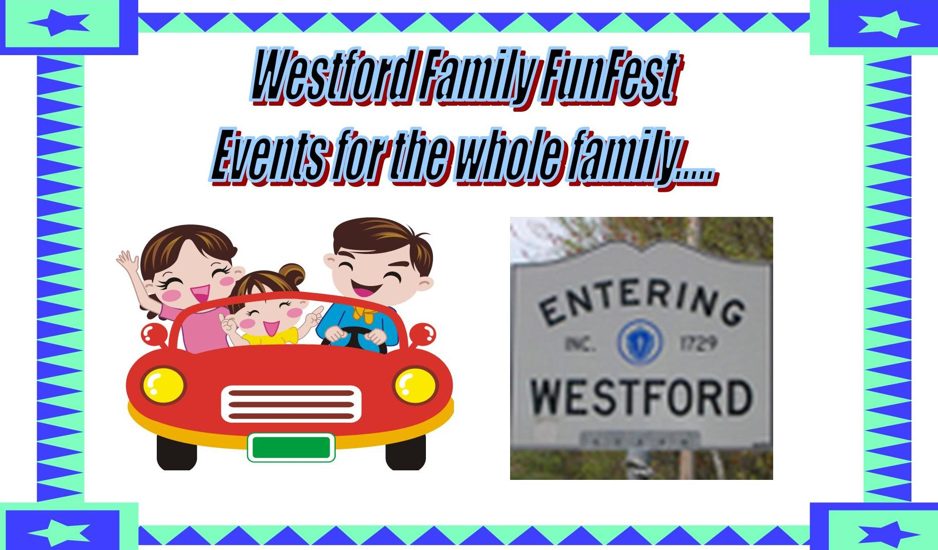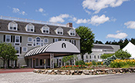

Westford Spring Festival Application 2018
Sponsored by the Westford Family FunFest and
& Westford Regency Inn March 16 – April 2, 2018

Held at the Westford Regency Inn 219 Littleton Rd. Westford, MA 01886

All Entries must fill out this section:
Name of organization, business/civic or individual: _________________________________________
Contact person(s): ______________________________________________________________________
Address__________________________________ City, State and zip code _________________________
Phone (home or business) _________________________ cell (optional) __________________________
Email _____________________________________________________________________________

Division Entered: Please check for one or more of the divisions. Give details below
__ Spring or Easter Wreath __ Creative Gingerbread – real/ artificial __ Fairy Gardens __ Gnome House

Wreath Division ___
Name or theme ____________________
Please describe in a few words ________________________________________________________________________________________
Size of Wreath in inches across - ____________(determine placement)

Gingerbread Creation Division: ___
Name or Theme:__________________________________ ___ Real or ___ Artificial Gingerbread materials
Please describe in a few words. ________________________________________________________________________________
Type: Single item __ OR Scene __ approximate display size _____ required to be displayed on a sturdy base.

Fairy Garden/Gnome House Division: ___

Name or Theme:________________________________________ ___ Fairy Garden ___ Gnome House ___
Please describe in a few words. ________________________________________________________________________________
Type: approximate display size _____ Required to be displayed in a sturdy container or sturdy base.

Drop off and set-up on Wednesday, March 14, 2018 between the hours of 2:00pm – 6pm. (unless arrangements are made) All areas must be kept clean and materials not used as part of display must be taken. (Please respect hotel guests/employees with no excess noise)

****All wreaths/ Gingerbread creations/ Fairy Gardens/ Gnome Houses, except Silent Auction items and winners must be picked up by Tuesday, April 2, 2018. From 2:00pm - 6pm, unless arrangements have been made. Area must be left clean.

Fundraising:
Silent Auction (which division) _________________ Yes______ or NFS(not for sale)_____

If Yes, Receive 100% of the funds from the Silent Auction bid or donate it to an organization.
Check off Division ___ Wreath ____ Gingerbread Creation _____ Fairy Garden ____Gnome House.
If you would like to donate your prize or Silent Auction amount to another organization, please let us know, so that winner knows who to make check out to. ______________________________________________
If you do not have an organization – the Westford Historical Society (WHS) Exhibit Fund is the supported organization the funds for Spring Festival 2018 event, if you like. WHS _______

Cost: Free, if registered by March 12, 2018 $10 after March 12, 2018 – make check payable to Westford FunFest if after March 12, 2018.
Mail to Westford Family FunFest P. O. Box 134 Westford, MA 01886 or email to funfest@westford.org. You will be notified of acceptance in the Festival/Contest by email and given final instructions. Email any questions?

